Mission Concept

Mission Concept

BYU Spacecraft Winter 2025 Mini Rover

# Program Objectives

The vision of the BYU Spacecraft Mini Rover Team is: *We will help students fulfill their dreams of becoming rover engineers by giving them hands-on learning experiences and opportunities that will prepare them to become creative, hard-working and proficient Rover Engineers.*

To meet this vision, the Mini Rover Team intends to design, build, test, and operate a mini rover as a baseline iteration for future designs and/or competitions in subsequent semesters. The success of the team will be measured by the following criteria:

1. Participants learn spacecraft project development and engineering teamwork.
2. Participants have opportunities to use and develop technical knowledge and experience.
3. Participants successfully meet rover mission objectives.

# Program Constraints

The Mini Rover team will consist of approximately 12 volunteer participants dedicating 1-2 hrs/week to the team. Of those, there will be selected key leads over mission systems.

The Projected budget is $1000-1500 for Winter 2025.

# Mission Objectives

The mission statement is: *Traverse the “Y” Mountain Trail from the base to the top of the Y to perform remote observation of the BYU Engineering Building by means of a live-operated rover.*

|  | **Mission Objective** | **Full Mission Success** | **Partial Mission Success** |
| --- | --- | --- | --- |
| **Primary** | The rover demonstrates remote observation of the BYU Engineering Building from the Y. | The Engineering Building is clearly visible in imaging data. | Any imaging data contains the Engineering Building. |
| The rover traverses by remote operation to the top of the “Y” and returns. | The rover traverses the return without physical assistance. | The rover traverses the return with occasional physical assistance. |
| **Secondary** | The rover is operated wirelessly. | Mission operations are conducted entirely from the base of the trail. | Mission operations are conducted within proximity of the rover. |

# Mission Constraints

The trail and trailhead are owned by Brigham Young University. The Mini Rover Team should coordinate with BYU to ensure compliant usage and establish additional mission constraints. Because the trail is publicly utilized, the mission must be safely accomplished with hikers sharing the trail. This may require additional safety measures (like human escorts of the rover) during traversal.

If radios are used for command and control, they must be compliant with FCC regulations.

# Preliminary System Design

The mission will consist of two physical systems, the Rover and the Mission Operations System (MOS).

1. Operations
   1. Operator training
   2. Operation parameters
   3. System transportation and deployment
2. Rover
   1. Optics
   2. Processing
   3. Movement
   4. Communications
   5. Power
   6. Structure
3. MOS
   1. Operator Interface
   2. Communications
   3. Support equipment

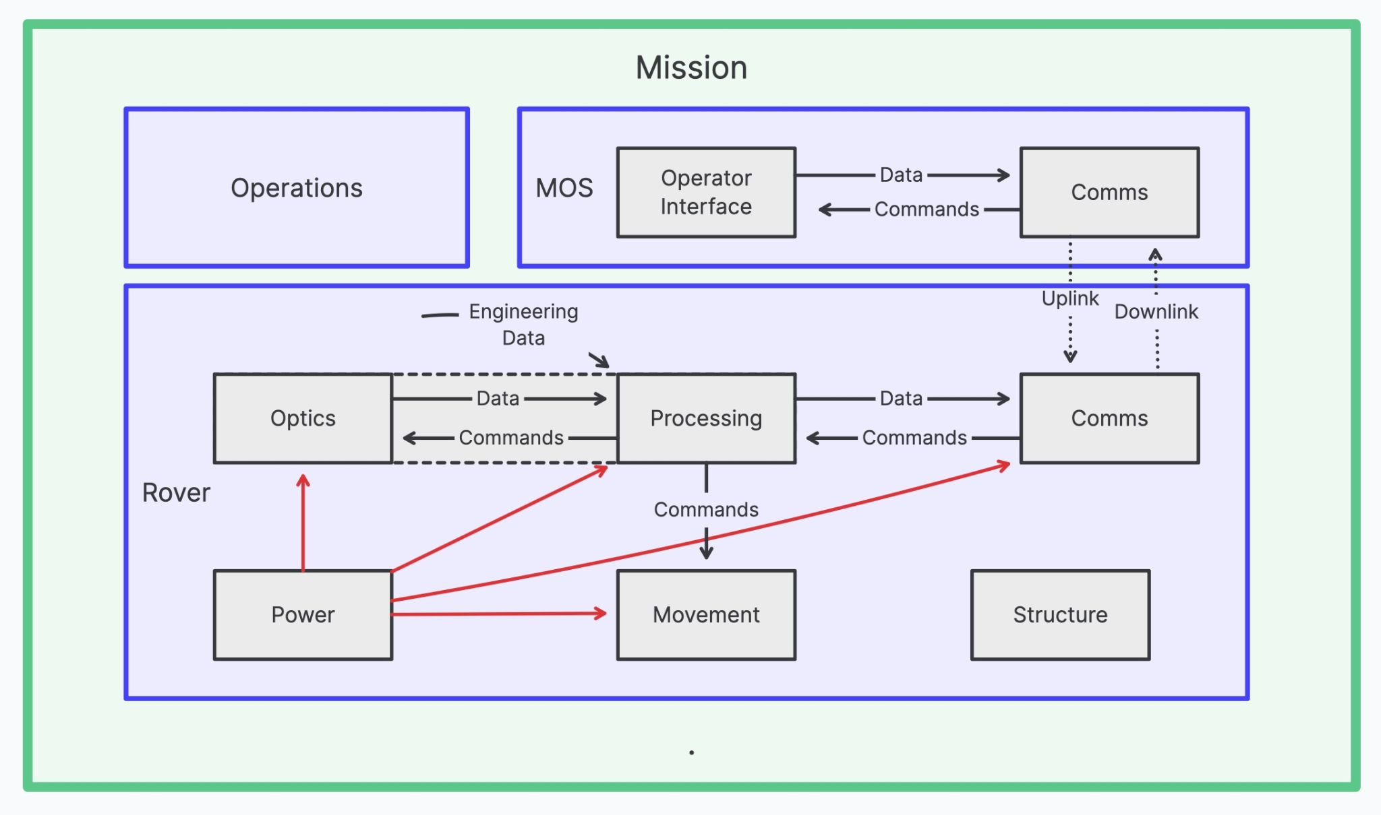

Mission Concept Review (MCR)

Mission Concept Review (MCR)

BYU Spacecraft Winter 2025 Mini Rover